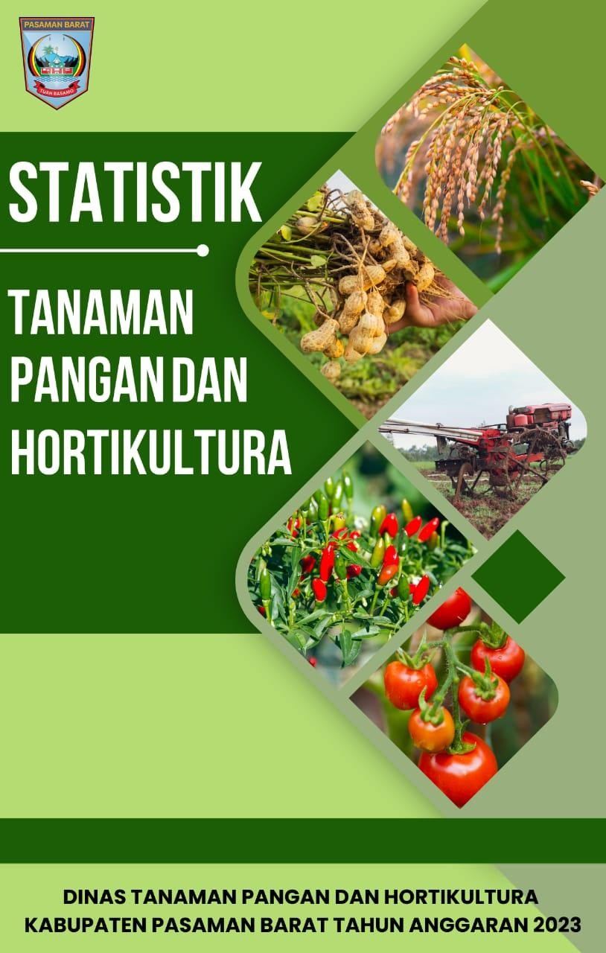

Pembangunan pertanian dititik beratkan kepada pemberdayaan ekonomi rakyat di pedesaan melalui program-program daerah dan program nasional, yang diharapkan dapat memacu laju pertumbuhan ekonomi secara menyeluruh. Kegiatan yang dilaksanakan pada hakekatnya merupakan upaya peningkatan pendapatan, peningkatan produksi pertanian dan peternakan.

Melalui buku statistik ini dapat diperoleh informasi tentang data-data mulai dari tanam, panen, produksi sampai produktivitas bidang pertanian. Buku statistik ini bertujuan untuk mengetahui capaian keberhasilan pembangunan Pasaman Barat di bidang pertanian dan peternakan dalam kurun waktu 5 tahun terakhir.

Dengan adanya Buku Statistik Dinas Tanaman Pangan dan Hortikultura Tahun Anggaran 2023 dapat digunakan sebagai acuan agar capaian target lebih ditingkatkan di masa yang akan datang.

Kepada semua pihak yang telah membantu Penyusunan Buku Statistik ini, kami ucapkan terima kasih. Penyusunan Buku Statistik ini juga mengharapkan kritik dan saran yang sifatnya membangun untuk kesempurnaannya, Semoga ALLAH SWT memberikan balasan yang setimpal amin.

Demikian Penyusunan Buku Statistik Dinas Tanaman Pangan dan Hortikultura akan (DTPH) Kabupaten Pasaman Barat Tahun Anggaran 2023 ini dibuat untuk diketahui dan dipedomani, terima kasih.

Sukamenanti, Juli 2023 Kepala Dinas Tanaman Pangan



dan Hortikultura Kabupaten Pasaman Barat

# drh. DODDY SAN ISMAIL, MM

# Pembina Tk.I/IV.b NIP. 19860331 201101 1 001

i

KATA PENGANTAR i

DAFTAR ISI ii

BAB I PENDAHULUAN 1

* 1. Latar Belakng 1
  2. Tujuan 1
  3. Maksud 2
  4. Ulasan 2

BAB II ISI 1

1. DATA STATISTIK TANAMAN PANGAN DAN HORTIKULTURA
   1. DATA TANAM, PANEN, PRODUKSI DAN PRODUKTIVITAS KOMODITI TANAMAN PANGAN TAHUN 2022
      1. Padi Sawah 4
      2. Padi Ladang 5
      3. Padi Total 6
      4. Jagung 7
      5. Kacang Tanah 8
      6. Ubi Kayu 9
      7. Ubi Jalar 10
      8. KacangHijau 11
   2. DATA TANAM, PANEN, PRODUKSI DAN PRODUKTIVITAS KOMODITI HORTIKULTURA (BUAH SAYURAN TAHUNAN) TAHUN 2022
      1. Pisang 12
      2. Alpokat 13
      3. Mangga 14
      4. Rambutan 15
      5. Duku 16
      6. Durian 17
      7. Nenas 18
      8. Jeruk 19
      9. Salak 20
      10. Pepaya 21
      11. Jambu Biji 22
      12. Manggis 23
   3. DATA TANAM, PANEN, PRODUKSI DAN PRODUKTIVITAS KOMODITI HORTIKULTURA (SAYURAN BUAH SEMUSIM) TAHUN 2022
      1. Cabe Keriting 24
      2. Ketimun 25
      3. Terung 26
      4. Kacang Panjang 27
      5. Bayam 28
      6. Kangkung 29
      7. Buncis 30
      8. Bawang Daun 31
      9. Petsai Sawi 32
      10. Cabe Rawit 33
      11. Semangka 34
   4. DATA ALAT DAN MESIN PERTANIAN 35

# BAB I PENDAHULUAN

* 1. Latar Belakang

Sektor pertanian merupakan salah satu sektor yang mempunyai peranan cukup penting dalam perekonomian Indonesia. Salah satu subsektor pertanian yang mempunyai peranan yang sangat strategis adalah tanaman pangan yang meliputi tanaman padi dan palawija. Subsektor tanaman pangan memiliki peran yang sangat strategis dalam hal pemenuhan kebutuhan pangan masyarakat. Karena itu, informasi mengenai produksi tanaman pangan hortikultura dan informasi pendukung lainnya yang akurat dan terkini sangat dibutuhkan oleh pemerintah sebagai masukan dalam formulasi dan penentuan kebijakan, khususnya terkait pemenuhan kebutuhan pangan masyarakat. Salah satu informasi penting yang dibutuhkan dalam perhitungan produksi tanaman pangan adalah informasil luas tanaman pangan dan hortikultura (luas tanam, luas panen, dan luas puso) yang dikumpulkan secara rutin melalui kegiatan Statistik Pertanian (SP). Selain informasi mengenai luas tanaman pangan dan hortikultura, dalam kegiatan SP juga dikumpulkan sejumlah informasi pendukung, seperti luas lahan pertanian, informasi penggunaan pupuk dan benih, serta alat dan mesin pertanian (alsintan).

Pembangunan pertanian dititik beratkan kepada pemberdayaan ekonomi rakyat di pedesaan melalui program-program daerah dan program nasional, yang diharapkan dapat memacu laju pertumbuhan ekonomi secara menyeluruh. Kegiatan yang dilaksanakan pada hakekatnya merupakan upaya peningkatan pendapatan, peningkatan produksi pertanian.

Melalui buku statistik ini dapat diperoleh informasi tentang data-data mulai dari tanam, panen, produksi sampai produktivitas bidang pertanian dan data-data yang berkaitan dengan pertanian. Buku statistik ini bertujuan untuk mengetahui capaian keberhasilan pembangunan Pasaman Barat di bidang pertanian dalam kurun waktu 5 tahun terakhir.

* 1. Tujuan

Tujuan pengumpulan data tanaman pangan adalah sebagai berikut:

* + 1. Memperoleh informasi mengenai luas tanam, luas panen, produksi dan produktivitas komoditas tanaman pangan dan hortikultura
    2. Memperoleh informasi penggunaan lahan, alat/mesin dan kelembagaan pertanian, serta perbenihan.
  1. Ruang Lingkup

Pengumpulan data Statistik Pertanian (SP) tanaman pangan mencakup seluruh kecamatan di Kabupaten Pasaman Barat.

* 1. Ulasan

Data statistik tahun 2021 dan 2022 terjadi penurunan produksi beberapa komoditi salah satunya padi dimana penurunan produksi padi, dari 109.883 ton pada Tahun 2021 menjadi 95.390 ton pada Tahun 2022. Penurunan ini sejalan dengan penurunan luas tanam komoditi padi, dari 22.956 hektar pada Tahun 2021 menjadi 19.906 hektar pada Tahun 2022. Penurunan produksi maupun luas tanam disebabkan oleh sejumlah permasalahan, antara lain terdapat bendungan di kecamatan gunung tuleh yang baru dibangun oleh PU melalui dana IPDMIP rusak kembali setelah hujan lebat. Selain itu di kecamatan talamau jaringan irigasi juga banyak yang rusak karena gempa tanggal 25 Februari 2022 sehingga petani ada yang beralih menanam komoditi lain.

Selain itu produksi jagung juga mengalami penurunan hal ini disebabkan karena petani Kabupaten Pasaman Barat fanatik dengan benih pioner 32 dimana saat itu benih tersebut langka di pasaran dan harga pupuk pun mahal. Petani tidak menanami lahannya sampai benih tersedia kembali. Selain itu jagung yang berintegrasi dengan sawit sudah tidak bisa ditanami lagi karena sawitnya sudah berumur lebih dari 2 tahun.

Untuk komoditi hortikultura seperti cabe mengalami sedikit penurunan dibandingkan tahun 2021 hal ini disebabkan karena cuaca yang ekstrim (sering hujan) menyebabkan OPT cabe berkembang seperti lalat buah, ulat grayak,

layu cendawan dan thrips sehingga cabe sehingga produksi sedikit menurun. Harga cabe menjadi mahal dipasaran yang menjadi salah satu penyebab terjadinya inflasi. Dalam rangka pengendalian inflasi di Kabupaten Pasaman Barat terdapat kegiatan bantuan bibit cabe, pupuk dan pestisida namun pendropingan dilakukan sudah di akhir tahun sehingga untuk produksinya masuk ketahun 2023.

Komoditi hortikultura lainnya yang mengalami penurunan adalah jeruk hal ini disebabkan karena tanaman jeruk banyak terserang OPT busuk pangkal batang dan lalat buah sehingga produksi menurun selain itu terdapat beberapa kecamatan yang mulai menanam kembali seperti di Kecamatan Ranah Batahan, Lembah Melintang dan Gunung Tuleh namun belum menghasilkan.

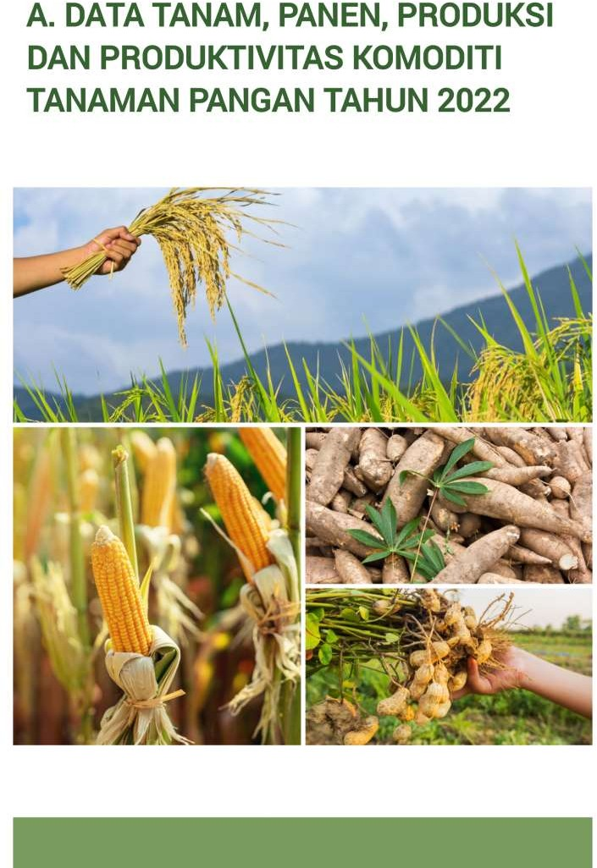

|  |  |  |  |
| --- | --- | --- | --- |
| **Kode.** | **Kecamatan** | **TAHUN 2022** | |
| **Tanam (Ha)** | **Panen (Ha)** |
| **1** | **2** | **3** | **4** |

131201 Sungai Beremas

|  |  |  |  |
| --- | --- | --- | --- |
|  | | 448 | 480 |
| 131207 | Ranah Batahan | 1,735 | 1,830 |
| 131208 | Koto Balingka | 407 | 464 |
| 131209 | Sungai Aur | 550 | 362 |
| 131202 | Lembah Melintang | 1,689 | 1,226 |
| 131206 | Gunung Tuleh | 1,024 | 957 |
| 131204 | Talamau | 3,569 | 4,393 |
| 131203 | Pasaman | 3,642 | 3,354 |
| 131210 | Luhak Nan Duo | 848 | 921 |
| 131211 | Sasak Ranah Pasisie | 27 | 18 |

131205 Kinali 2,934 2,666

|  |  |  |
| --- | --- | --- |
| **JUMLAH** | **16,872** | **16,670** |
| **2021** | **19,679** | **18,744** |
| **2020** | **27,069** | **27,488** |
| **2019** | **26,477** | **26,132** |
| **2018** |  |  |
|  | **24,668** | **26,490** |

|  |  |  |  |
| --- | --- | --- | --- |
| **Kode** | **Kecamatan** | **TAHUN 2022** | |
| **Tanam (Ha)** | **Panen (Ha)** |
| **1** | **2** | **3** | **4** |

131201 Sungai Beremas

|  |  |  |  |
| --- | --- | --- | --- |
|  | | 88 | 400 |
| 131207 | Ranah Batahan | 100 | 301 |
| 131208 | Koto Balingka | 358 | 530 |
| 131209 | Sungai Aur | 859 | 773 |
| 131202 | Lembah Melintang | 38 | 38 |
| 131206 | Gunung Tuleh | 468 | 97 |
| 131204 | Talamau | 110 | 128 |
| 131203 | Pasaman | 274 | 370 |
| 131210 | Luhak Nan Duo | 67 | 77 |
| 131211 | Sasak Ranah Pasisie | 78 | 157 |

131205 Kinali - -

|  |  |  |
| --- | --- | --- |
| **JUMLAH** | **2.440** | **2,871** |
| **2021** | **3,277** | **4,147** |
| **2020** | **4,241** | **6,461** |
| **2019** | **8,159** | **6,367** |
| **2018** | **7,322** | **6,204** |

**3. PADI TOTAL**

|  |  |  |  |  |  |
| --- | --- | --- | --- | --- | --- |
| **Kode** | **Kecamatan** | **Tanam (Ha)** | **TAHUN 2022**  **Panen (Ha) Produksi**  **(Ton)** | | **Produktivitas (Ton/Ha)** |
| **1** | **2** | **3** | **4** | **5** | **6** |

|  |  |  |  |  |  |
| --- | --- | --- | --- | --- | --- |
| 131201 | Sungai Beremas | 536 | 880 | 4,314 | 4.90 |
| 131207 | Ranah Batahan | 1,835 | 2,131 | 10,442 | 4.90 |
| 131208 | Koto Balingka | 765 | 994 | 4,870 | 4.90 |
| 131209 | Sungai Aur | 1,409 | 1,135 | 5,562 | 4.90 |
| 131202 | Lembah Melintang | 1,727 | 1,264 | 6,195 | 4.90 |
| 131206 | Gunung Tuleh | 1,492 | 1,054 | 5,165 | 4.90 |
| 131204 | Talamau | 3,679 | 4,521 | 22,153 | 4.90 |
| 131203 | Pasaman | 3,916 | 3,724 | 18,246 | 4.90 |
| 131210 | Luhak Nan Duo | 915 | 998 | 4,890 | 4.90 |
| 131211 | Sasak Ranah Pasisie | 105 | 175 | 856 | 4.90 |
| 131205 | Kinali | 2,934 | 2,666 | 13,062 | 4.90 |

|  |  |  |  |  |
| --- | --- | --- | --- | --- |
| **JUMLAH** | **19,312** | **19,541** | **95,753** | **4.90** |
| **2021** | **22,956** | **22,891** | **109,884** | **4.80** |
| **2020** | **31,489** | **33,949** | **147,471** | **4.34** |
| **2019** | **34,606** | **32,499** | **138,322** | **4.26** |
| **2018** | **31,900** | **32,694** | **159,942** | **4.89** |

|  |  |  |  |  |  |
| --- | --- | --- | --- | --- | --- |
| **Kode** | **Kecamatan** | **Tanam (Ha)** | **TAHUN 2022**  **Panen (Ha) Produksi**  **(Ton)** | | **Produktivitas (Ton/Ha)** |
| **1** | **2** | **3** | **4** | **5** | **6** |

|  |  |  |  |  |  |
| --- | --- | --- | --- | --- | --- |
| 131201 | Sungai Beremas | 3,743 | 3,541 | 22,946 | 6.40 |
| 131207 | Ranah Batahan | 4,330 | 4,091 | 26,506 | 6.40 |
| 131208 | Koto Balingka | 3,102 | 2,684 | 17,392 | 6.40 |
| 131209 | Sungai Aur | 1,527 | 1,448 | 9,383 | 6.40 |
| 131202 | Lembah Melintang | 1,438 | 1,651 | 10,698 | 6.40 |
| 131206 | Gunung Tuleh | 667 | 651 | 4,218 | 6.40 |
| 131204 | Talamau | 4,042 | 4,104 | 26,593 | 6.40 |
| 131203 | Pasaman | 6,849 | 5,489 | 35,569 | 6.40 |
| 131210 | Luhak Nan Duo | 4,826 | 4,639 | 30,063 | 6.40 |
| 131211 | Sasak Ranah Pasisie | 171 | 258 | 1,672 | 6.40 |
| 131205 | Kinali | 4,978 | 5,835 | 37,813 | 6.40 |

|  |  |  |  |  |
| --- | --- | --- | --- | --- |
| **JUMLAH** | **35,673** | **34,391** | **222,855** | **6.40** |
| **2021** | **44,096** | **43,757** | **266,912** | **6.10** |
| **2020** | **43,889** | **43,190** | **262,510** | **6.08** |
| **2019** | **45,593** | **50,936** | **311,576** | **6.12** |
| **2018** | **46,146** | **56,864** | **367,865** | **6.47** |

|  |  |  |  |  |  |
| --- | --- | --- | --- | --- | --- |
| **Kode** | **Kecamatan** | **Tanam (Ha)** | **TAHUN 2022**  **Panen (Ha) Produksi**  **(Ton)** | | **Produktivitas (Ton/Ha)** |
| **1** | **2** | **3** | **4** | **5** | **6** |

|  |  |  |  |  |  |
| --- | --- | --- | --- | --- | --- |
| 131201 | Sungai Beremas | 18 | 19 | 30,4 | 1.60 |
| 131207 | Ranah Batahan | 22 | 19 | 30,4 | 1.60 |
| 131208 | Koto Balingka | 0 | 4 | 6,4 | 1.60 |
| 131209 | Sungai Aur | 62 | 61 | 97,60 | 1.60 |
| 131202 | Lembah Melintang | 39 | 36 | 57,60 | 1.60 |
| 131206 | Gunung Tuleh | 249 | 264 | 422,40 | 1.60 |
| 131204 | Talamau | 8 | 9 | 14,40 | 1.60 |
| 131203 | Pasaman | 31 | 31 | 49,60 | 1.60 |
| 131210 | Luhak Nan Duo | 14 | 11 | 17,60 | 1.60 |
| 131211 | Sasak Ranah Pasisie | 7 | 5 | 8,00 | 1.60 |
| 131205 | Kinali | 11 | 11 | 17,60 | 1.60 |

|  |  |  |  |  |
| --- | --- | --- | --- | --- |
| **JUMLAH** | **461** | **470** | **752** | **1.60** |
| **2021** | **535** | **519** | **831** | **1.60** |
| **2020** | **474** | **482** | **582** | **1.21** |
| **2019** | **450,9** | **451,9** | **537,76** | **1.19** |
| **2018** | **432** | **456** | **623** | **1.37** |

|  |  |  |  |  |  |
| --- | --- | --- | --- | --- | --- |
| **Kode** | **Kecamatan** | **Tanam (Ha)** | **TAHUN 2022**  **Panen (Ha)** | **Produksi (Ton)** | **Produktivitas (Ton/Ha)** |
| **1** | **2** | **3** | **4** | **5** | **6** |

|  |  |  |  |  |  |
| --- | --- | --- | --- | --- | --- |
| 131201 | Sungai Beremas | 12 | 11 | 403 | 36.60 |
| 131207 | Ranah Batahan | 12 | 8 | 293 | 36.60 |
| 131208 | Koto Balingka | 2 | 2 | 73 | 36.60 |
| 131209 | Sungai Aur | 0 | 11 | 403 | 36.60 |
| 131202 | Lembah Melintang | 18 | 15 | 549 | 36.60 |
| 131206 | Gunung Tuleh | 5 | 4 | 146 | 36.60 |
| 131204 | Talamau | 73 | 22 | 805 | 36.60 |
| 131203 | Pasaman | 21 | 29 | 1,061 | 36.60 |
| 131210 | Luhak Nan Duo | 13 | 7 | 256 | 36.60 |
| 131211 | Sasak RanahPasisie | 6 | 4 | 146 | 36.60 |
| 131205 | Kinali | 1 | 1 | 37 | 36.60 |

|  |  |  |  |  |  |
| --- | --- | --- | --- | --- | --- |
| **JUMLAH** | | **163** | **114** | **4,172** | **36.60** |
|  | | | | | |
|  | **2021** | **153** | **154** | **5,698** | **37.00** |
| **2020** | **141** | **121** | **3,450** | **28.52** |
| **2019** | **196** | **214** | **8,289** | **38.73** |
| **2018** | **209** | **220** | **8,533** | **38.73** |

1. **UBI JALAR**

|  |  |  |  |  |  |
| --- | --- | --- | --- | --- | --- |
| **Kode** | **Kecamatan** | **Tanam (Ha)** | **TAHUN 2022**  **Panen (Ha) Produksi**  **(Ton)** | | **Produktivitas (Ton/Ha)** |
| **1** | **2** | **3** | **4** | **5** | **6** |

|  |  |  |  |  |  |
| --- | --- | --- | --- | --- | --- |
| 131201 | Sungai Beremas | 19 | 18 | 560 | 31.10 |
| 131207 | Ranah Batahan | 17 | 18 | 560 | 31.10 |
| 131208 | Koto Balingka | 21 | 16 | 498 | 31.10 |
| 131209 | Sungai Aur | - | - | - | - |
| 131202 | Lembah Melintang | 18 | 15 | 467 | 31.10 |
| 131206 | Gunung Tuleh | 3 | 4 | 124 | 31.10 |
| 131204 | Talamau | 79 | 55 | 1,711 | 31.10 |
| 131203 | Pasaman | 13 | 19 | 591 | 31.10 |
| 131210 | Luhak Nan Duo | 13 | 10 | 311 | 31.10 |
| 131211 | Sasak Ranah Pasisie | 8 | 7 | 218 | 31.10 |
| 131205 | Kinali | 2 | 1 | 31 | 31.10 |

|  |  |  |  |  |
| --- | --- | --- | --- | --- |
| **JUMLAH** | **193** | **163** | **5,069** | **31.10** |
| **2021** | **222** | **214** | **6,683** | **31.23** |
| **2020** | **197,98** | **200** | **6,155.2** | **30.78** |
| **2019** | **235** | **241** | **8,198.10** | **34.02** |
| **2018** | **390** | **390** | **13,270** | **34.02** |

1. **KACANG HIJAU**

|  |  |  |  |  |  |
| --- | --- | --- | --- | --- | --- |
| **Kode** | **Kecamatan** | **Tanam (Ha)** | **TAHUN 2022**  **Panen (Ha)** | **Produksi (Ton)** | **Produktivitas (Ton/Ha)** |
| **1** | **2** | **3** | **4** | **5** | **6** |

|  |  |  |  |  |  |
| --- | --- | --- | --- | --- | --- |
| 131201 | Sungai Beremas | 6 | 10 | 14 | 1.40 |
| 131207 | Ranah Batahan | 2 | 3 | 4 | 1.40 |
| 131208 | Koto Balingka | 18 | 15 | 21 | 1.40 |
| 131209 | Sungai Aur | - | - | - | - |
| 131202 | Lembah Melintang | 35 | 37 | 52 | 1.40 |
| 131206 | Gunung Tuleh | 113 | 106 | 148 | 1.40 |
| 131204 | Talamau | - | - | - | - |
| 131203 | Pasaman | 24 | 27 | 38 | 1.40 |
| 131210 | Luhak Nan Duo | 3 | 5 | 7 | 1.40 |
| 131211 | Sasak Ranah Pasisie | 9 | 9 | 13 | 1.40 |
| 131205 | Kinali | 1 | 1 | 1 | 1.40 |

|  |  |  |  |  |  |
| --- | --- | --- | --- | --- | --- |
| **JUMLAH** | | **211** | **213** | **298** | **1.40** |
|  | **2021** | **234** | **205** | **890** | **4.3** |
|  | **2020** | **176** | **183** | **931** | **5.07** |
|  | **2019** | **164** | **163** | **223** | **1.37** |
| **2018** | **131** | **128** | **175** | **1.3** |

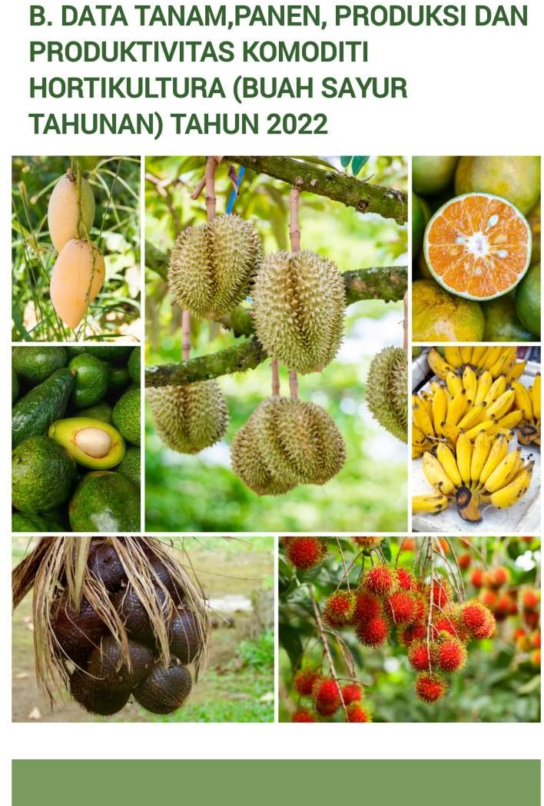

|  |  |  |  |  |  |
| --- | --- | --- | --- | --- | --- |
| **Kode** | **Kecamatan** | **Tanam (Ha)** | **TAHUN 2022**  **Panen (Ha) Produksi**  **(Ton)** | | **Produktivitas (Ton/Ha)** |
| **1** | **2** | **3** | **4** | **5** | **6** |

|  |  |  |  |  |  |
| --- | --- | --- | --- | --- | --- |
| 131201 | Sungai Beremas | 33.05 | 5.31 | 97.1 | 18.29 |
| 131207 | Ranah Batahan | 3.09 | 0.36 | 24.1 | 66.94 |
| 131208 | Koto Balingka | 9.01 | 1.40 | 71.4 | 51.00 |
| 131209 | Sungai Aur | 5.88 | 0.66 | 49.7 | 75.30 |
| 131202 | Lembah Melintang | 27.33 | 4.00 | 269.9 | 67.50 |
| 131206 | Gunung Tuleh | 52.26 | 9.58 | 206.4 | 21.54 |
| 131204 | Talamau | 21.42 | 2.22 | 145.7 | 65.63 |
| 131203 | Pasaman | 28.26 | 6.29 | 477.4 | 75.90 |
| 131210 | Luhak Nan Duo | 25.65 | 1.86 | 88.7 | 47.69 |
| 131211 | Sasak Ranah Pasisie | 8.65 | 0.70 | 46.3 | 66.14 |
| 131205 | Kinali | 7.10 | 1.73 | 78.0 | 45.08 |

|  |  |  |  |  |
| --- | --- | --- | --- | --- |
| **JUMLAH** | **221.69** | **34,10** | **1,554.6** | **45,57** |
| **2021** | **54.8** | **37.10** | **2.425.19** | **65.37** |
| **2020** | **51.99** | **30.97** | **1.477.78** | **47.72** |
| **2019** | **49.42** | **131.82** | **4.517.15** | **34.27** |
| **2018** | **152.74** | **42.52** | **1.487.56** | **34.99** |

|  |  |  |  |  |  |
| --- | --- | --- | --- | --- | --- |
| **Kode** | **Kecamatan** | **Tanam (Ha)** | **TAHUN 2022**  **Panen (Ha) Produksi**  **(Ton)** | | **Produktivitas (Ton/Ha)** |
| **1** | **2** | **3** | **4** | **5** | **6** |

|  |  |  |  |  |  |
| --- | --- | --- | --- | --- | --- |
| 131201 | Sungai Beremas | 32.38 | 5.93 | 35.46 | 5.98 |
| 131207 | Ranah Batahan | 21.25 | 3.00 | 24.60 | 8.20 |
| 131208 | Koto Balingka | 17.72 | 4.43 | 31.25 | 7.05 |
| 131209 | Sungai Aur | 30.19 | 3.49 | 22.68 | 6.50 |
| 131202 | Lembah Melintang | 103.60 | 20.00 | 131.18 | 6.56 |
| 131206 | Gunung Tuleh | 35.21 | 5.00 | 22.52 | 4.50 |
| 131204 | Talamau | 274.70 | 24.69 | 218.52 | 8.85 |
| 131203 | Pasaman | 1,188.41 | 87.60 | 610.92 | 6.97 |
| 131210 | Luhak Nan Duo | 5,232.72 | 887.76 | 8,170.90 | 9.20 |
| 131211 | Sasak Ranah Pasisie | 264.72 | 14.60 | 125.68 | 8.61 |
| 131205 | Kinali | 1,420.95 | 348.00 | 3,223.97 | 9.26 |

|  |  |  |  |  |
| --- | --- | --- | --- | --- |
| **JUMLAH** | **8,621.85** | **1,404.50** | **12,617.67** | **8.98** |
| **2021** | **2,146.90** | **1,175.82** | **4,636** | **3,94** |
| **2020** | **2,202.25** | **273,02** | **2,396,08** | **8,78** |
| **2019** | **1,702.60** | **188,13** | **818,10** | **4,35** |
| **2018** | **231,40** | **59,69** | **391,34** | **6,56** |

|  |  |  |  |  |  |
| --- | --- | --- | --- | --- | --- |
| **Kode** | **Kecamatan** | **Tanam (Ha)** | **TAHUN 2022**  **Panen (Ha) Produksi (Ton)** | | **Produktivitas (Ton/Ha)** |
| **1** | **2** | **3** | **4** | **5** | **6** |

|  |  |  |  |  |  |
| --- | --- | --- | --- | --- | --- |
| 131201 | Sungai Beremas | 141.83 | 34.16 | 120 | 3.51 |
| 131207 | Ranah Batahan | 56.46 | 8.48 | 105.2 | 12.41 |
| 131208 | Koto Balingka | 54.80 | 9.45 | 89.4 | 9.46 |
| 131209 | Sungai Aur | 16.99 | 1.21 | 76 | 62.80 |
| 131202 | Lembah Melintang | 38.84 | 10.02 | 106 | 10.57 |
| 131206 | Gunung Tuleh | 34.72 | 5.92 | 41.2 | 6.95 |
| 131204 | Talamau | 59.24 | 7.89 | 99.4 | 12.59 |
| 131203 | Pasaman | 238.63 | 10.37 | 138.6 | 13.37 |
| 131210 | Luhak Nan Duo | 33.32 | 1.74 | 25.6 | 14.71 |
| 131211 | Sasak Ranah Pasisie | 94.44 | 6.60 | 73.6 | 11.15 |
| 131205 | Kinali | 67.24 | 15.00 | 103.4 | 6.89 |

|  |  |  |  |  |
| --- | --- | --- | --- | --- |
| **JUMLAH** | **836.51** | **110.84** | **909.90** | **8.20** |
| **2021** | **209.30** | **113.11** | **1.161** | **10.26** |
| **2020** | **210.60** | **83.30** | **896.70** | **10.77** |
| **2019** | **150.00** | **98.33** | **1.101** | **11.20** |
| **2018** | **148.85** | **108.76** | **1.059.22** | **9.74** |

|  |  |  |  |  |  |
| --- | --- | --- | --- | --- | --- |
| **Kode** | **Kecamatan** | **Tanam (Ha)** | **TAHUN 2022**  **Panen (Ha) Produksi**  **(Ton)** | | **Produktivitas (Ton/Ha)** |
| **1** | **2** | **3** | **4** | **5** | **6** |

|  |  |  |  |  |  |
| --- | --- | --- | --- | --- | --- |
| 131201 | Sungai Beremas | 29.75 | 3.40 | 20.20 | 5.94 |
| 131207 | Ranah Batahan | 6.82 | 1.00 | 10.95 | 10.95 |
| 131208 | Koto Balingka | 64.14 | 10.21 | 80.12 | 7.85 |
| 131209 | Sungai Aur | 55.72 | 7.94 | 55.11 | 6.94 |
| 131202 | Lembah Melintang | 8.69 | 5.00 | 32.50 | 6.50 |
| 131206 | Gunung Tuleh | 19.40 | 2.00 | 4.35 | 2.18 |
| 131204 | Talamau | 1.03 | 0.19 | 2.12 | 11.15 |
| 131203 | Pasaman | 37.06 | 4.39 | 39.03 | 8.89 |
| 131210 | Luhak Nan Duo | 243.72 | 50.35 | 435.31 | 8.64 |
| 131211 | Sasak Ranah Pasisie | 55.26 | 10.00 | 23.25 | 2.32 |
| 131205 | Kinali | 29.16 | 6.00 | 25.25 | 4.21 |

|  |  |  |  |  |
| --- | --- | --- | --- | --- |
| **JUMLAH** | **550.75** | **100.48** | **728.17** | **7.24** |
| **2021** | **147.35** | **116.83** | **568.30** | **4.86** |
| **2020** | **157.39** | **87.73** | **296.00** | **3.57** |
| **2019** | **168.38** | **73.68** | **263.14** | **3.57** |
| **2018** | **170.00** | **118.00** | **533.00** | **4.51** |

|  |  |  |  |  |  |
| --- | --- | --- | --- | --- | --- |
| **Kode** | **Kecamatan** | **Tanam (Ha)** | **TAHUN 2022**  **Panen (Ha) Produksi**  **(Ton)** | | **Produktivitas (Ton/Ha)** |
| **1** | **2** | **3** | **4** | **5** | **6** |

|  |  |  |  |  |  |
| --- | --- | --- | --- | --- | --- |
| 131201 | Sungai Beremas | 7.21 | 0.68 | 2.62 | 3.85 |
| 131207 | Ranah Batahan | 1.72 | - | 0 | - |
| 131208 | Koto Balingka | 13.49 | 1.85 | 8.24 | 4.45 |
| 131209 | Sungai Aur | 1.84 | 0.20 | 0.5 | 2.50 |
| 131202 | Lembah Melintang | 2.91 | 0.65 | 3.61 | 5.55 |
| 131206 | Gunung Tuleh | 8.82 | 1.20 | 5.92 | 4.93 |
| 131204 | Talamau | - | - | - | - |
| 131203 | Pasaman | 1.24 | 0.05 | 0.13 | 2.50 |
| 131210 | Luhak Nan Duo | 4.60 | 0.15 | 1.12 | 7.46 |
| 131211 | Sasak Ranah Pasisie | - | - | - | - |
| 131205 | Kinali | 40.76 | 9.00 | 29.9 | 3.33 |

|  |  |  |  |  |
| --- | --- | --- | --- | --- |
| **JUMLAH** | **82.59** | **13.78** | **52.11** | **3.78** |
| **2021** | **20.51** | **8.73** | **57.80** | **6.62** |
| **2020** | **13.10** | **9.20** | **32.41** | **3.52** |
| **2019** | **10.83** | **4.14** | **13.20** | **3.19** |
| **2018** | **11.17** | **7.48** | **23.88** | **3.19** |

|  |  |  |  |  |  |
| --- | --- | --- | --- | --- | --- |
| **Kode** | **Kecamatan** | **Tanam (Ha)** | **TAHUN 2022**  **Panen (Ha) Produksi**  **(Ton)** | | **Produktivitas (Ton/Ha)** |
| **1** | **2** | **3** | **4** | **5** | **6** |

|  |  |  |  |  |  |
| --- | --- | --- | --- | --- | --- |
| 131201 | Sungai Beremas | 73.66 | 13.45 | 71.60 | 5.32 |
| 131207 | Ranah Batahan | 176.44 | 25.00 | 153.20 | 6.12 |
| 131208 | Koto Balingka | 50.50 | 7.80 | 108.6 | 13.92 |
| 131209 | Sungai Aur | 26.39 | 5.89 | 22.60 | 3.84 |
| 131202 | Lembah Melintang | 56.15 | 7.50 | 59.50 | 7.93 |
| 131206 | Gunung Tuleh | 57.24 | 8.30 | 28.40 | 3.42 |
| 131204 | Talamau | 39.90 | 5.54 | 29.70 | 5.36 |
| 131203 | Pasaman | 108.51 | 10.97 | 165.40 | 15.08 |
| 131210 | Luhak Nan Duo | 135.34 | 15.45 | 214.70 | 13.89 |
| 131211 | Sasak Ranah Pasisie | 32.79 | 2.00 | 10.00 | 5.00 |
| 131205 | Kinali | 54.61 | 10.00 | 46.10 | 4.61 |

|  |  |  |  |  |
| --- | --- | --- | --- | --- |
| **JUMLAH** | **811.53** | **111.90** | **909.60** | **9.69** |
| **2021** | **198.63** | **123.72** | **1.107.13** | **8.95** |
| **2020** | **205.27** | **100.92** | **902.50** | **8.94** |
| **2019** | **218.19** | **59.39** | **561.18** | **9.45** |
| **2018** | **220.00** | **148.00** | **1.671.00** | **11.32** |

|  |  |  |  |  |  |
| --- | --- | --- | --- | --- | --- |
| **Kode** | **Kecamatan** | **Tanam (Ha)** | **TAHUN 2022**  **Panen (Ha) Produksi**  **(Ton)** | | **Produktivitas (Ton/Ha)** |
| **1** | **2** | **3** | **4** | **5** | **6** |

|  |  |  |  |  |  |
| --- | --- | --- | --- | --- | --- |
| 131201 | Sungai Beremas | 0.01 | 0.00 | 0.34 | 170 |
| 131207 | Ranah Batahan | 0.09 | 0.02 | 2.89 | 144.5 |
| 131208 | Koto Balingka | 0.22 | 0.05 | 6.23 | 124.6 |
| 131209 | Sungai Aur | 0.07 | 0.02 | 2.72 | 136 |
| 131202 | Lembah Melintang | 0.12 | 0.01 | 1.59 | 159 |
| 131206 | Gunung Tuleh | 0.15 | 0.01 | 1.96 | 196 |
| 131204 | Talamau | 0.05 | 0.01 | 1.22 | 122 |
| 131203 | Pasaman | 0.32 | 0.04 | 7.32 | 183 |
| 131210 | Luhak Nan Duo | 0.11 | 0.01 | 2.54 | 254 |
| 131211 | Sasak Ranah Pasisie | 0.06 | 0.01 | 0.66 | 66 |
| 131205 | Kinali | 0.06 | 0.01 | 2.13 | 213 |

|  |  |  |  |  |
| --- | --- | --- | --- | --- |
| **JUMLAH** | **1.27** | **0.19** | **29.59** | **155.73** |
| **2021** | **0.29** | **0.16** | **33.89** | **212.58** |
| **2020** | **0.32** | **0.07** | **9.82** | **135.167** |
| **2019** | **0.16** | **0.07** | **10.50** | **151.74** |
| **2018** | **0.18** | **0.14** | **11.83** | **82.84** |

|  |  |  |  |  |  |
| --- | --- | --- | --- | --- | --- |
| **Kode** | **Kecamatan** | **Tanam (Ha)** | **TAHUN 2022**  **Panen (Ha) Produksi**  **(Ton)** | | **Produktivitas (Ton/Ha)** |
| **1** | **2** | **3** | **4** | **5** | **6** |

|  |  |  |  |  |  |
| --- | --- | --- | --- | --- | --- |
| 131201 | Sungai Beremas | 73.26 | 16.57 | 306.10 | 18.47 |
| 131207 | Ranah Batahan | 96.70 | 10.53 | 252.10 | 23.94 |
| 131208 | Koto Balingka | 422.12 | 82.40 | 1,832.70 | 22.24 |
| 131209 | Sungai Aur | 75.57 | 15.43 | 359.20 | 23.27 |
| 131202 | Lembah Melintang | 257.45 | 41.25 | 1,026.80 | 24.89 |
| 131206 | Gunung Tuleh | 680.82 | 94.50 | 1,722.80 | 18.23 |
| 131204 | Talamau | 5.78 | 1.03 | 20.30 | 19.71 |
| 131203 | Pasaman | 452.61 | 48.03 | 756.20 | 15.74 |
| 131210 | Luhak Nan Duo | 13.54 | 1.57 | 39.00 | 24.84 |
| 131211 | Sasak Ranah Pasisie | 91.41 | 14.41 | 264.70 | 18.36 |
| 131205 | Kinali | 74.62 | 17.60 | 395.50 | 22.47 |

|  |  |  |  |  |
| --- | --- | --- | --- | --- |
| **JUMLAH** | **2.243.88** | **343.33** | **69.755** | **28.75** |
| **2021** | **570.55** | **365.02** | **10.241** | **28.06** |
| **2020** | **631.99** | **1.011** | **12.303** | **12.17** |
| **2019** | **767.68** | **374.94** | **9.718** | **25.92** |
| **2018** | **810.24** | **567.35** | **9.464** | **16.68** |

|  |  |  |  |  |  |
| --- | --- | --- | --- | --- | --- |
| **Kode** | **Kecamatan** | **Tanam (Ha)** | **TAHUN 2022**  **Panen (Ha) Produksi**  **(Ton)** | | **Produktivitas (Ton/Ha)** |
| **1** | **2** | **3** | **4** | **5** | **6** |

|  |  |  |  |  |  |
| --- | --- | --- | --- | --- | --- |
| 131201 | Sungai Beremas | - | - | - | - |
| 131207 | Ranah Batahan | 0.05 | 0.01 | 0.7 | 70.00 |
| 131208 | Koto Balingka | 0.35 | 0.05 | 2.7 | 54.00 |
| 131209 | Sungai Aur | 0.43 | 0.05 | 1.2 | 24.00 |
| 131202 | Lembah Melintang | - | - | - | - |
| 131206 | Gunung Tuleh | 0.29 | 0.03 | 0.9 | 30.00 |
| 131204 | Talamau | 0.43 | 0.09 | 5.4 | 60.00 |
| 131203 | Pasaman | 0.34 | 0.08 | 4.5 | 56.25 |
| 131210 | Luhak Nan Duo | 0.17 | 0.05 | 2 | 40.00 |
| 131211 | Sasak Ranah Pasisie | - | - | - | - |
| 131205 | Kinali | - | - | - | - |

|  |  |  |  |  |
| --- | --- | --- | --- | --- |
| **JUMLAH** | **2.06** | **0.36** | **17.4** | **48.33** |
| **2021** | **0.62** | **0.54** | **30.37** | **55.93** |
| **2020** | **1.09** | **0.90** | **15.06** | **16.70** |
| **2019** | **4.17** | **2.98** | **28.77** | **9.66** |
| **2018** | **5.61** | **4.00** | **70.20** | **17.54** |

|  |  |  |  |  |  |
| --- | --- | --- | --- | --- | --- |
| **Kode** | **Kecamatan** | **Tanam (Ha)** | **TAHUN 2022**  **Panen (Ha) Produksi**  **(Ton)** | | **Produktivitas (Ton/Ha)** |
| **1** | **2** | **3** | **4** | **5** | **6** |

|  |  |  |  |  |  |
| --- | --- | --- | --- | --- | --- |
| 131201 | Sungai Beremas | 2.81 | 0.63 | 44.10 | 70.00 |
| 131207 | Ranah Batahan | 1.71 | 0.30 | 23.10 | 77.00 |
| 131208 | Koto Balingka | 15.84 | 2.80 | 170.10 | 60.75 |
| 131209 | Sungai Aur | 4.76 | 0.79 | 47.10 | 59.62 |
| 131202 | Lembah Melintang | 20.57 | 3.48 | 206.40 | 59.31 |
| 131206 | Gunung Tuleh | 7.62 | 0.99 | 61.20 | 61.81 |
| 131204 | Talamau | 15.40 | 2.67 | 116.60 | 43.67 |
| 131203 | Pasaman | 15.91 | 0.99 | 74.70 | 75.45 |
| 131210 | Luhak Nan Duo | 9.70 | 2.22 | 140.60 | 63.33 |
| 131211 | Sasak Ranah Pasisie | 7.96 | 1.90 | 102.30 | 53.84 |
| 121305 | Kinali | 112.16 | 27.50 | 1,582.80 | 57.56 |

|  |  |  |  |  |
| --- | --- | --- | --- | --- |
| **JUMLAH** | **214.45** | **44.27** | **2,569.1** | **58.03** |
| **2021** | **53.41** | **41.05** | **3,171.71** | **77.27** |
| **2020** | **54.75** | **12.56** | **804.60** | **64.04** |
| **2019** | **24.459** | **9.971** | **529.92** | **53.15** |
| **2018** | **21.08** | **16.47** | **456.83** | **27.74** |

|  |  |  |  |  |  |
| --- | --- | --- | --- | --- | --- |
| **Kode** | **Kecamatan** | **Tanam (Ha)** | **TAHUN 2022**  **Panen (Ha) Produksi (Ton)** | | **Produktivitas (Ton/Ha)** |
| **1** | **2** | **3** | **4** | **5** | **6** |

|  |  |  |  |  |  |
| --- | --- | --- | --- | --- | --- |
| 131201 | Sungai Beremas | 13.29 | 2.67 | 17.56 | 6.59 |
| 131207 | Ranah Batahan | - | - | - |  |
| 131208 | Koto Balingka | 16.02 | 2.09 | 41.85 | 19.99 |
| 131209 | Sungai Aur | 9.09 | 1.08 | 17.53 | 16.23 |
| 131202 | Lembah Melintang | 8.17 | 1.69 | 27.24 | 16.15 |
| 131206 | Gunung Tuleh | 10.78 | 0.87 | 14.6 | 16.85 |
| 131204 | Talamau | 0.81 | 0.14 | 1.27 | 9.07 |
| 131203 | Pasaman | 18.73 | 3.43 | 71.60 | 20.87 |
| 131210 | Luhak Nan Duo | 18.28 | 2.09 | 44.14 | 21.11 |
| 131211 | Sasak Ranah Pasisie | 4.42 | 0.48 | 9.07 | 18.89 |
| 131205 | Kinali | 10.53 | 2.33 | 25.85 | 11.09 |

|  |  |  |  |  |
| --- | --- | --- | --- | --- |
| **JUMLAH** | **101.12** | **16.87** | **270.72** | **16.04** |
| **2021** | **27.27** | **19.28** | **341.63** | **17.72** |
| **2020** | **31.29** | **11.66** | **224.26** | **19.23** |
| **2019** | **29.04** | **16.18** | **344.85** | **21.31** |
| **2018** | **27.6** | **18.08** | **180.50** | **9.98** |

|  |  |  |  |  |  |
| --- | --- | --- | --- | --- | --- |
| **Kode** | **Kecamatan** | **Tanam (Ha)** | **TAHUN 2022**  **Panen (Ha) Produksi (Ton)** | | **Produktivitas (Ton/Ha)** |
| **1** | **2** | **3** | **4** | **5** | **6** |

|  |  |  |  |  |  |
| --- | --- | --- | --- | --- | --- |
| 131201 | Sungai Beremas | 3.68 | 0.76 | 5.97 | 7.85 |
| 131207 | Ranah Batahan | 4.12 | 1.03 | 12.59 | 12.22 |
| 131208 | Koto Balingka | 13.27 | 2.92 | 10.33 | 3.53 |
| 131209 | Sungai Aur | 28.64 | 4.03 | 34.26 | 8.50 |
| 131202 | Lembah Melintang | 25.33 | 4 | 14.34 | 3.58 |
| 131206 | Gunung Tuleh | 65.33 | 7.09 | 28.14 | 3.96 |
| 131204 | Talamau | 285.41 | 47.2 | 233.18 | 4.94 |
| 131203 | Pasaman | 33.30 | 5.47 | 49.05 | 8.96 |
| 131210 | Luhak Nan Duo | 12.68 | 0.28 | 2.97 | 10.60 |
| 131211 | Sasak Ranah Pasisie | 14.46 | 3.53 | 6.05 | 1,71 |
| 131205 | Kinali | 34.44 | 8 | 28.67 | 3.58 |

|  |  |  |  |  |
| --- | --- | --- | --- | --- |
| **JUMLAH** | **520.66** | **117.71** | **425.51** | **3.61** |
| **2021** | **488.05** | **60.25** | **339.07** | **5.63** |
| **2020** | **418.10** | **34.16** | **188.70** | **5.52** |
| **2019** | **302.81** | **23.27** | **185.70** | **7.98** |
| **2018** | **256.39** | **41.85** | **312.1** | **0.13** |

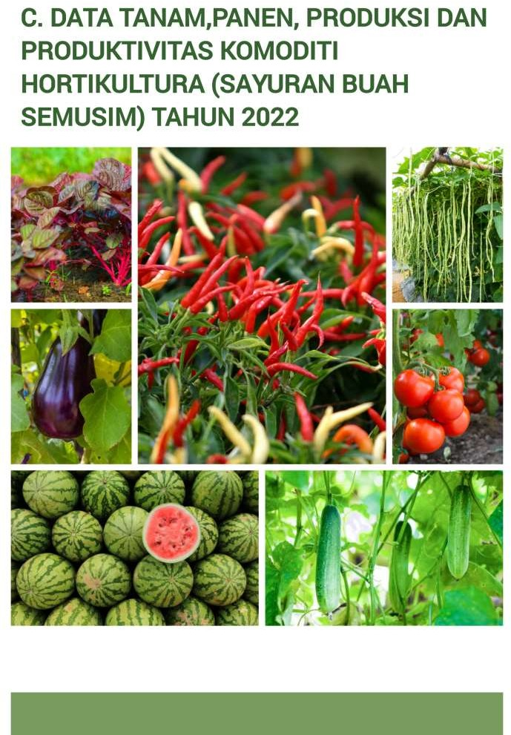

|  |  |  |  |  |  |
| --- | --- | --- | --- | --- | --- |
| **Kode** | **Kecamatan** | **Tanam (Ha)** | **TAHUN 2022**  **Panen (Ha) Produksi**  **(Ton)** | | **Produktivitas (Ton/Ha)** |
| **1** | **2** | **3** | **4** | **5** | **6** |

|  |  |  |  |  |  |
| --- | --- | --- | --- | --- | --- |
| 131201 | Sungai Beremas | 30 | 37 | 233.5 | 6.31 |
| 131207 | Ranah Batahan | 33 | 28 | 335.5 | 11.98 |
| 131208 | Koto Balingka | 43 | 37 | 258.5 | 6.98 |
| 131209 | Sungai Aur | 26 | 30 | 257.0 | 8.56 |
| 131202 | Lembah Melintang | 211 | 205 | 1,638.5 | 8.00 |
| 131206 | Gunung Tuleh | 57 | 88 | 660.5 | 7.50 |
| 131204 | Talamau | 42 | 61 | 422.5 | 6.92 |
| 131203 | Pasaman | 51 | 62 | 413.0 | 6.67 |
| 131210 | Luhak Nan Duo | 45 | 50 | 327.3 | 6.54 |
| 131211 | Sasak Ranah Pasisie | 25 | 30 | 209.5 | 6.99 |
| 131205 | Kinali | 69 | 71 | 467.5 | 6.58 |

|  |  |  |  |  |
| --- | --- | --- | --- | --- |
| **JUMLAH** | **632** | **699** | **5,223.30** | **7.47** |
| **2021** | **565** | **1,758** | **5,689.30** | **3.24** |
| **2020** | **496** | **605** | **9,147.50** | **15.11** |
| **2019** | **495** | **495** | **4,614.40** | **9.32** |
| **2018** | **303** | **433** | **3,122.60** | **7.21** |

|  |  |  |  |  |  |
| --- | --- | --- | --- | --- | --- |
| **Kode** | **Kecamatan** | **Tanam (Ha)** | **TAHUN 2022**  **Panen (Ha) Produksi**  **(Ton)** | | **Produktivitas (Ton/Ha)** |
| **1** | **2** | **3** | **4** | **5** | **6** |

|  |  |  |  |  |  |
| --- | --- | --- | --- | --- | --- |
| 131201 | Sungai Beremas | 15 | 16 | 145.50 | 9.09 |
| 131207 | Ranah Batahan | 23 | 22 | 254.50 | 11.57 |
| 131208 | Koto Balingka | 4 | 8 | 105.00 | 13.13 |
| 131209 | Sungai Aur | 28 | 25 | 221.00 | 8.84 |
| 131202 | Lembah Melintang | 17 | 18 | 186.50 | 10.36 |
| 131206 | Gunung Tuleh | 14 | 14 | 138.00 | 9.86 |
| 131204 | Talamau | 22. | 18 | 201.00 | 11.17 |
| 131203 | Pasaman | 28 | 27 | 296.50 | 10.98 |
| 131210 | Luhak Nan Duo | 22 | 21 | 219.00 | 10.43 |
| 131211 | Sasak Ranah Pasisie | 6 | 7 | 69.50 | 9.93 |
| 131205 | Kinali | 13 | 22 | 233.00 | 10.59 |

|  |  |  |  |  |
| --- | --- | --- | --- | --- |
| **JUMLAH** | **192** | **198** | **2,069.50** | **11.59** |
| **2021** | **193** | **410** | **4,964.00** | **12.11** |
| **2020** | **225** | **237** | **3,525.50** | **14.87** |
| **2019** | **202** | **227** | **2,158.40** | **9.51** |
| **2018** | **154.15** | **161** | **1,476.20** | **9.17** |

|  |  |  |  |  |  |
| --- | --- | --- | --- | --- | --- |
| **Kode** | **Kecamatan** | **Tanam (Ha)** | **TAHUN 2022**  **Panen (Ha) Produksi**  **(Ton)** | | **Produktivitas (Ton/Ha)** |
| **1** | **2** | **3** | **4** | **5** | **6** |

|  |  |  |  |  |  |
| --- | --- | --- | --- | --- | --- |
| 131201 | Sungai Beremas | 11 | 14 | 84.00 | 6.00 |
| 131207 | Ranah Batahan | 26.00 | 25 | 184.00 | 7.36 |
| 131208 | Koto Balingka | 24.00 | 22 | 126.50 | 5.75 |
| 131209 | Sungai Aur | 24.00 | 21 | 124.50 | 5.93 |
| 131202 | Lembah Melintang | 15.00 | 18 | 97.00 | 5.39 |
| 131206 | Gunung Tuleh | 18.00 | 25 | 127.00 | 5.08 |
| 131204 | Talamau | 1.00 | 5 | 21.20 | 4.24 |
| 131203 | Pasaman | 22.00 | 25 | 127.30 | 5.09 |
| 131210 | Luhak Nan Duo | 28.00 | 36 | 203.80 | 5.66 |
| 131211 | Sasak Ranah Pasisie | 6.00 | 6 | 30.00 | 5.00 |
| 131205 | Kinali | 16.00 | 27 | 180.50 | 6.69 |

|  |  |  |  |  |
| --- | --- | --- | --- | --- |
| **JUMLAH** | **191** | **224** | **1,305.80** | **5.82** |
| **2021** | **214** | **975** | **9.273** | **9.51** |
| **2020** | **265** | **306** | **6.770** | **22.12** |
| **2019** | **212** | **282** | **3.747** | **13.29** |
| **2018** | **213** | **275** | **2.208** | **8.03** |

**4. KACANG PANJANG**

|  |  |  |  |  |  |
| --- | --- | --- | --- | --- | --- |
| **Kode** | **Kecamatan** | **Tanam (Ha)** | **TAHUN 2022**  **Panen (Ha)** | **Produksi (Ton)** | **Produktivitas (Ton/Ha)** |
| **1** | **2** | **3** | **4** | **5** | **6** |

|  |  |  |  |  |  |
| --- | --- | --- | --- | --- | --- |
| 131201 | Sungai Beremas | 17 | 19 | 117.50 | 6.18 |
| 131207 | Ranah Batahan | 26.00 | 33 | 448.00 | 3.57 |
| 131208 | Koto Balingka | 26.00 | 29 | 184.00 | 6.34 |
| 131209 | Sungai Aur | 24.00 | 25 | 158.80 | 6.35 |
| 131202 | Lembah Melintang | 43.00 | 49 | 325.50 | 6.44 |
| 131206 | Gunung Tuleh | 29.00 | 35 | 238.00 | 6.80 |
| 131204 | Talamau | 25.00 | 23 | 120.00 | 5.21 |
| 131203 | Pasaman | 28.00 | 30 | 183.50 | 6.11 |
| 131210 | Luhak Nan Duo | 27.00 | 28 | 173.00 | 6.17 |
| 131211 | Sasak Ranah Pasisie | 10.00 | 9 | 47.50 | 5.27 |
| 131205 | Kinali | 23.00 | 27 | 178.00 | 6.59 |

|  |  |  |  |  |
| --- | --- | --- | --- | --- |
|  | | | | |
| **JUMLAH** | **278** | **307** | **2,173.00** | **7.07** |
|  | | | | |
| **2021** | **231.00** | **678.00** | **4.129.60** | **6.09** |
| **2020** | **250.00** | **260.00** | **226.80** | **0.87** |
| **2019** | **246.00** | **303.00** | **168.07** | **0.55** |
| **2018** | **233.50** | **249.00** | **113.74** | **4.57** |

|  |  |  |  |  |  |
| --- | --- | --- | --- | --- | --- |
| **Kode** | **Kecamatan** | **Tanam (Ha)** | **TAHUN 2022**  **Panen (Ha) Produksi**  **(Ton)** | | **Produktivitas (Ton/Ha)** |
| **1** | **2** | **3** | **4** | **5** | **6** |

|  |  |  |  |  |  |
| --- | --- | --- | --- | --- | --- |
| 131201 | Sungai Beremas | 19 | 20 | 82 | 4.10 |
| 131207 | Ranah Batahan | 3.00 | 4 | 20 | 5.00 |
| 131208 | Koto Balingka | 12.00 | 13 | 56 | 4.31 |
| 131209 | Sungai Aur | 29.00 | 28 | 122 | 4.36 |
| 131202 | Lembah Melintang | 24.00 | 23 | 100 | 4.35 |
| 131206 | Gunung Tuleh | 21.00 | 25 | 112 | 4.48 |
| 131204 | Talamau | 19.00 | 19 | 81 | 4.26 |
| 131203 | Pasaman | 7.00 | 7 | 29 | 4.14 |
| 131210 | Luhak Nan Duo | 24.00 | 24 | 106 | 4.42 |
| 131211 | Sasak Ranah Pasisie | 12.00 | 12 | 53 | 4.41 |
| 131205 | Kinali | 23.00 | 23 | 141 | 6.13 |

|  |  |  |  |  |  |
| --- | --- | --- | --- | --- | --- |
|  |  | | | | |
| **JUMLAH** | **193** | **198** | **902** | **4.55** |
|  | | | | | |
|  | **2021** | **171.00** | **171.00** | **1,229.30** | **7.19** |
| **2020** | **164.00** | **159.00** | **731.90** | **4.60** |
| **2019** | **154.00** | **167.00** | **435.90** | **2.61** |
| **2018** | **127.50** | **150.50** | **370.20** | **2.46** |

|  |  |  |  |  |  |
| --- | --- | --- | --- | --- | --- |
| **Kode** | **Kecamatan** | **Tanam (Ha)** | **TAHUN 2022**  **Panen (Ha) Produksi**  **(Ton)** | | **Produktivitas (Ton/Ha)** |
| **1** | **2** | **3** | **4** | **5** | **6** |

|  |  |  |  |  |  |
| --- | --- | --- | --- | --- | --- |
| 131201 | Sungai Beremas | 9 | 10 | 63 | 6.30 |
| 131207 | Ranah Batahan | 9.00 | 9 | 67.50 | 7.50 |
| 131208 | Koto Balingka | 23.00 | 20 | 188.00 | 9.40 |
| 131209 | Sungai Aur | 31.00 | 28 | 215.00 | 7.67 |
| 131202 | Lembah Melintang | 22.00 | 21 | 193.50 | 9.21 |
| 131206 | Gunung Tuleh | 12.00 | 14 | 137.00 | 9.78 |
| 131204 | Talamau | 25.00 | 19 | 147.00 | 7.73 |
| 131203 | Pasaman | - | - | - | - |
| 131210 | Luhak Nan Duo | 22.00 | 22 | 153.50 | 6.97 |
| 131211 | Sasak Ranah Pasisie | 12.00 | 12 | 63.00 | 5.25 |
| 131205 | Kinali | 23.00 | 21 | 176.00 | 8.38 |

|  |  |  |  |  |
| --- | --- | --- | --- | --- |
| **JUMLAH** | **188** | **176** | **1,403.50** | **7.97** |
| **2021** | **139.00** | **142.00** | **987.00** | **6.95** |
| **2020** | **175.00** | **182.00** | **1060.00** | **5.82** |
| **2019** | **166.00** | **173.00** | **479.40** | **2.77** |
| **2018** | **134.80** | **163.50** | **326.00** | **1.99** |

|  |  |  |  |  |  |
| --- | --- | --- | --- | --- | --- |
| **Kode** | **Kecamatan** | **Tanam (Ha)** | **TAHUN 2022**  **Panen (Ha) Produksi**  **(Ton)** | | **Produktivitas (Ton/Ha)** |
| **1** | **2** | **3** | **4** | **5** | **6** |

|  |  |  |  |  |  |
| --- | --- | --- | --- | --- | --- |
| 131201 | Sungai Beremas | - | - | - | - |
| 131207 | Ranah Batahan | - | - | - | - |
| 131208 | Koto Balingka | - | - | - | - |
| 131209 | Sungai Aur | - | - | - | - |
| 131202 | Lembah Melintang | - | - | - | - |
| 131206 | Gunung Tuleh | - | - | - | - |
| 131204 | Talamau | 34 | 24 | 113 | 4.70 |
| 131203 | Pasaman | 19 | 8 | 82.5 | 10.1 |
| 131210 | Luhak Nan Duo | 2 | 2 | 7 | 3.50 |
| 131211 | Sasak Ranah Pasisie | - | - | - | - |
| 131205 | Kinali | 17 | 17 | 78.5 | 4.61 |

|  |  |  |  |  |
| --- | --- | --- | --- | --- |
| **JUMLAH** | **72** | **61** | **281** | **4.60** |
| **2021** | **25** | **28.** | **256** | **9.14** |
| **2020** | **11** | **13** | **156** | **12.00** |
| **2019** | **14** | **25** | **174.5** | **6.98** |
| **2018** | **15** | **14** | **215.5** | **15.39** |

|  |  |  |  |  |  |
| --- | --- | --- | --- | --- | --- |
| **Kode** | **Kecamatan** | **Tanam (Ha)** | **TAHUN 2022**  **Panen (Ha) Produksi**  **(Ton)** | | **Produktivitas (Ton/Ha)** |
| **1** | **2** | **3** | **4** | **5** | **6** |

|  |  |  |  |  |  |
| --- | --- | --- | --- | --- | --- |
| 131201 | Sungai Beremas | - | - | - | - |
| 131207 | Ranah Batahan | - | - | - | - |
| 131208 | Koto Balingka | - | - | - | - |
| 131209 | Sungai Aur | - | - | - | - |
| 131202 | Lembah Melintang | - | - | - | - |
| 131206 | Gunung Tuleh | - | - | - | - |
| 131204 | Talamau | 19.00 | 18 | 84.00 | 4.67 |
| 131203 | Pasaman | 5.00 | 4 | 8.00 | 2.00 |
| 131210 | Luhak Nan Duo | - | - | - | - |
| 131211 | Sasak Ranah Pasisie | - | - | - | - |
| 131205 | Kinali | - | - | - | - |

|  |  |  |  |  |
| --- | --- | --- | --- | --- |
| **JUMLAH** | **24** | **22** | **92** | **4.18** |
| **2021** | **12.00** | **12.00** | **83.00** | **6.92** |
| **2020** | **19.00** | **22.00** | **73.90** | **3.36** |
| **2019** | **-** | **-** | **-** | **-** |
| **2018** | **21.00** | **34.00** | **777.00** | **22.85** |

**2021**

**2020**

**2019**

**2018**

|  |  |  |  |  |  |
| --- | --- | --- | --- | --- | --- |
| **Kode** | **Kecamatan** | **Tanam (Ha)** | **TAHUN 2022**  **Panen (Ha) Produksi**  **(Ton)** | | **Produktivitas (Ton/Ha)** |
| **1** | **2** | **3** | **4** | **5** | **6** |

|  |  |  |  |  |  |
| --- | --- | --- | --- | --- | --- |
| 131201 | Sungai Beremas | - | - | - | - |
| 131207 | Ranah Batahan | - | - | - | - |
| 131208 | Koto Balingka | - | - | - | - |
| 131209 | Sungai Aur | - | - | - | - |
| 131202 | Lembah Melintang | - | - | - | - |
| 131206 | Gunung Tuleh | - | - | - | - |
| 131204 | Talamau | - | - | - | - |
| 131203 | Pasaman | - | - | - | - |
| 131210 | Luhak Nan Duo | 20 | 20 | 96 | 4.80 |
| 131211 | Sasak Ranah Pasisie | - | - | - | - |
| 131205 | Kinali | - | - | - | - |
|  | **JUMLAH** | **20** | **20** | **96** | **4.80** |

|  |  |  |  |
| --- | --- | --- | --- |
| **19**  **-** | **21**  **-** | **176**  **-** | **8.38**  **-** |
| **-** | **-** | **-** | **-** |
| **-** | **-** | **-** | **-** |

|  |  |  |  |  |  |
| --- | --- | --- | --- | --- | --- |
| **Kode** | **Kecamatan** | **Tanam (Ha)** | **TAHUN 2022**  **Panen (Ha) Produksi**  **(Ton)** | | **Produktivitas (Ton/Ha)** |
| **1** | **2** | **3** | **4** | **5** | **6** |

|  |  |  |  |  |  |
| --- | --- | --- | --- | --- | --- |
| 131201 | Sungai Beremas | 32 | 43 | 175.90 | 2.94 |
| 131207 | Ranah Batahan | 29.00 | 31 | 282.70 | 12.29 |
| 131208 | Koto Balingka | 32.00 | 36 | 158.80 | 6.62 |
| 131209 | Sungai Aur | 27.00 | 31 | 134.10 | 4.97 |
| 131202 | Lembah Melintang | 224.00 | 286 | 1,S292.60 | 6.07 |
| 131206 | Gunung Tuleh | 80.00 | 100 | 447.00 | 5.32 |
| 131204 | Talamau | 24.00 | 30 | 123.80 | 7.02 |
| 131203 | Pasaman | 35.00 | 47 | 203.90 | 8.44 |
| 131210 | Luhak Nan Duo | 29.00 | 32 | 131.00 | 7.71 |
| 131211 | Sasak Ranah Pasisie | 15.00 | 14 | 55.90 | 5.08 |
| 131205 | Kinali | 28.00 | 38 | 175.40 | 6.75 |

|  |  |  |  |  |
| --- | --- | --- | --- | --- |
| **JUMLAH** | **555** | **688** | **3,181.10** | **5.98** |
| **2021** | **404** | **1,761** | **2,862.4** | **1.63** |
| **2020** | **392** | **443** | **7,277.5** | **16.43** |
| **2019** | **349** | **449** | **4,697.7** | **10.46** |
| **2018** | **320.8** | **519** | **5,424.3** | **10.45** |

**11. SEMANGKA**

|  |  |  |  |  |  |
| --- | --- | --- | --- | --- | --- |
| **Kode** | **Kecamatan** | **Tanam(Ha)** | **TAHUN 2022**  **Panen (Ha) Produksi(Ton)** | | **Produktivitas (Ton/Ha)** |
| **1** | **2** | **3** | **4** | **5** | **6** |

|  |  |  |  |  |  |
| --- | --- | --- | --- | --- | --- |
| 131201 | Sungai Beremas | 10 | 13 | 78 | 6.00 |
| 131207 | Ranah Batahan | 14.00 | 14 | 81 | 5.79 |
| 131208 | Koto Balingka | - |  | - | - |
| 131209 | Sungai Aur | - |  | - | - |
| 131202 | Lembah Melintang | - |  | - | - |
| 131206 | Gunung Tuleh | - |  | - | - |
| 131204 | Talamau | - |  | - | - |
| 131203 | Pasaman | 31 | 30 | 193 | 6.43 |
| 131210 | Luhak Nan Duo | 14 | 16 | 99 | 6.19 |
| 131211 | Sasak Ranah Pasisie | 10 | 10 | 56.6 | 5.66 |
| 131205 | Kinali | 28 | 33 | 203 | 6.15 |

|  |  |  |  |  |
| --- | --- | --- | --- | --- |
| **JUMLAH** | **107** | **116** | **711** | **6.12** |
| **2021** | **100** | **101** | **1,341** | **13.28** |
| **2020** | **165** | **173** | **2,486.3** | **14.37** |
| **2019** | **168** | **182** | **1,522.2** | **8.36** |
| **2018** | **130.5** | **154.5** | **794.15** | **5.14** |

**D. DATA ALAT DAN MESIN PERTANIAN**

|  |  |  |  |
| --- | --- | --- | --- |
| **TAHUN 2022** | | | |
| **Kode Kecamatan Hand Traktor**  **Big Scale Small Traktor**  **Rice Scale Rice Roda 4**  **Milling Milling** | **Power Thresher** | **Seed Cleaner** | **Corn Sheller** |
| **1 2 3 4 5 6** | **7** | **8** | **9** |
| 13 12 01 Sungai - - 13 -  Beremas  13 12 07 Ranah 2 12 52 -  Batahan  13 12 08 Koto Balingka - 14 5 -  13 12 09 Sungai Aur 3 - 9 -  13 12 02 Lembah 2 2 9 -  Melintang  13 12 06 Gunung Tuleh - - 25 -  13 12 04 Talamau 1 5 62 -  13 12 03 Pasaman 4 22 89 4  13 12 10 Luhak Nan 7 - 410 2  Duo  13 12 11 Sasak Ranah - 2 1 -  Pasisie  13 12 05 Kinali - - 187 - | 13  250  10  15  47  18  68  34  60  5  35 | -  -  -  4  10  15  -  21  37  -  - | 8  200  8  3  18  11  6  93  64  -  49 |
| **JUMLAH 19 57 862 6** | **555** | **87** | **460** |
| **2021 19 90 781 6**  **2020 42 96 915 5**  **2019 20 92 915 7**  **2018 22 99 937 7** | **598**  **729**  **586**  **585** | **137**  **269**  **138**  **150** | **373**  **474**  **374**  **386** |